# CS 255 System Design Document

## UML Diagrams

### UML Use Case Diagram

### UML Activity Diagrams

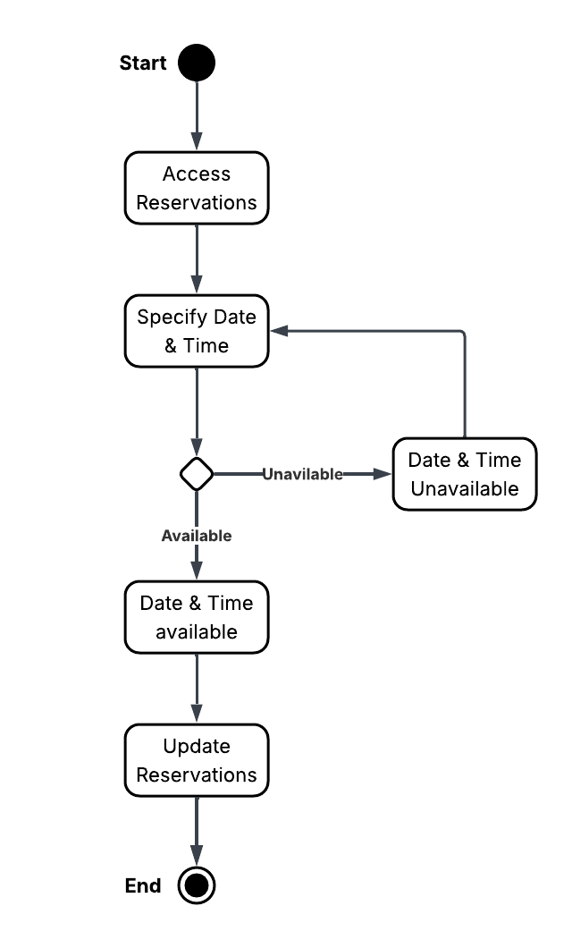

### UML Sequence Diagram

### UML Class Diagram

## Technical Requirements

* System requires stable internet connection–DriverPass is an online service who uses cloud software and a third party database service. Internet connection is paramount to the system’s success and connecting clients to the server.
* Hosted via cloud server such as AWS or Azure–AWS or Azure are examples of cloud platforms DriverPass can utilize for their system
* Consistent DMV information updates via APIs–using a DMV API that can regularly check for new information and send the new information to the lessons is vital for DriverPass to release and stay updated with current policies, rule, regulations, etc.
* Cross-platform compatible–DriverPass’ clients are assumed to be operating on various platforms and DriverPass must ensure their website is compatible to desktops, laptops, mobile devices, etc.
* Cross-browser compatible–again DriverPass’ clients are expected to be operating on various browsers and the system must it’s compatible to various browsers
* 5 second initial load page and video stream buffering response time–quick load times for pages and videos is of importance to ensure a smooth and timely experience for DriverPass’ customers.
* 3 second internal navigation response time–a specified short time for internal navigation because there should be less that needs to be loaded depending on the action.
* Intuitive and consistent UI–keeping a consistent UI will enhance experience and building an intuitive layout will assist customers in learning and navigating the website.
* Separate database to hold user and course information such as MySQL or PostgreSQL–specific examples of database services DriverPass can utilize.
* RBAC policies for admin, secretary, and customers–RBAC to ensure each user has only the specified access allowable to them.
* Admin must be able to access and manipulate all account information–additional access specified for the admin role.
* Secretary must have access to all customers’ reservation portals–additional information regarding the secretary’s system access.
* Customers must have complete access to only their account–basic information regarding the access customers have.
* <1 second error notification response time–error should be displayed quickly and with pertinent information to fix the error.
* System will perform automated compatibility checks with supported platforms–this ensures DriverPass stay compatible for its users.
* Frequent testing on various platforms–testing is vital to ensuring the system works as expected across different platforms.
* Fast deployment of updates and patches (within 1 week)–DriverPass should expect the need for updates and patches based off of software, hardware, and other compatible changes. Staying up to date with these fixes will ensure a smooth experience for DriverPass’ customers.
* System will utilize TLS for secure data exchange–a specified industry standard security protocol to ensure user data is protected and secured.
* Third-party payment processing tool such as stripe or PayPal–specific payment processing services DriverPass may use.
* System will log authentication attempts and flag suspicious activity–important for the admin’s system reports to review and protect users and the system.
* System will auto-scale to support peak usage hours–a cloud platform can scale easily allowing DriverPass to handle large amounts of clients.
* System will include basic usage analytics–another important component for the admin’s system report.
* System will support modular design for easier updates–modular designs are useful in maintenance mode and can prevent tedious and large workloads.